Practical 1:-

Step 1: Open Google Chrome and login with your account

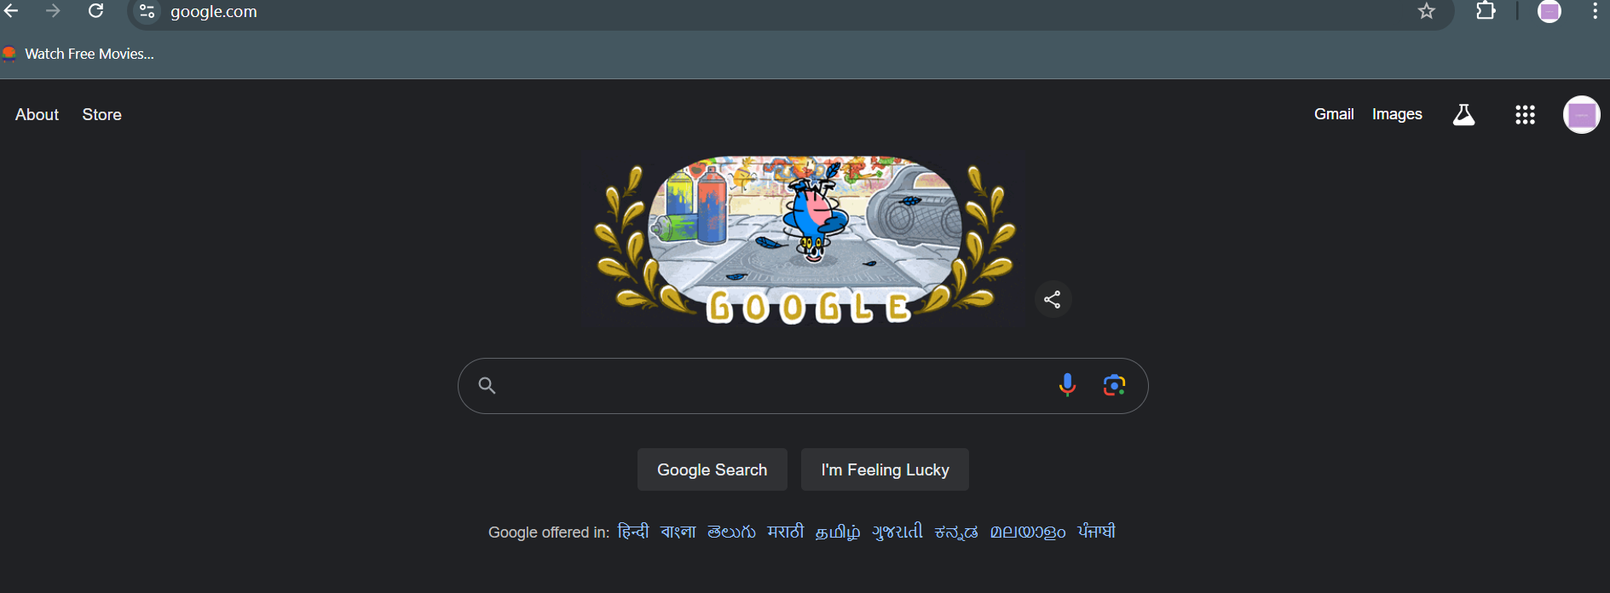

Step 2: Then search google sheet

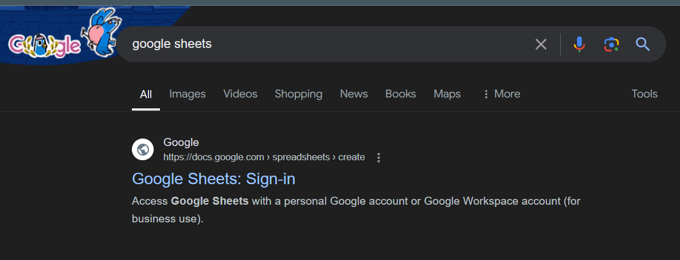

Step 3: Open it

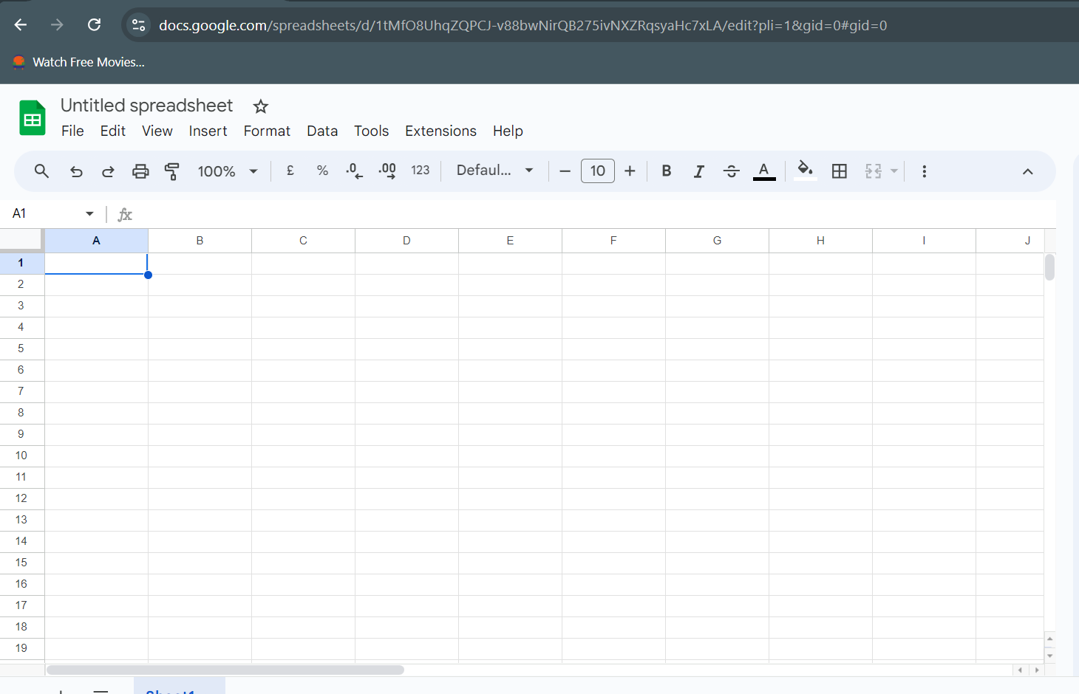

Step 4: Make a random table

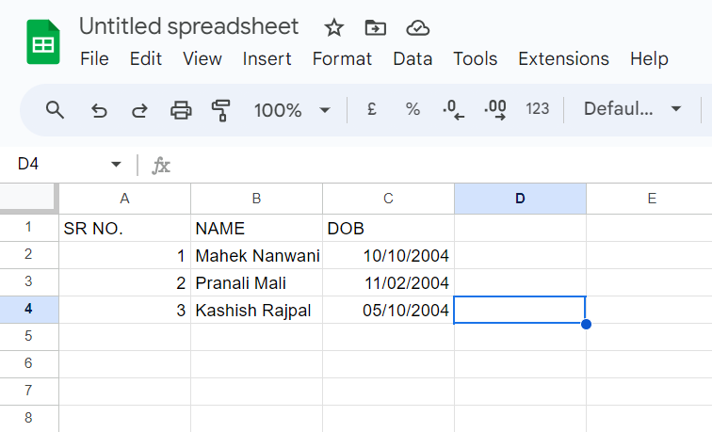

Step 5: Save in mydrive

